**Midterm Lab Task Set 1**

**Python Basic Input-Output/Operators/Escape sequence**

**and Placeholders**

**Problem 1. Using print statement**

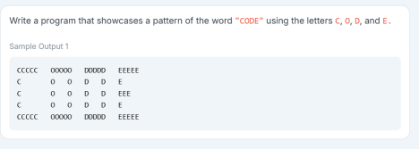

**Problem 2. Using Escape Sequence. Use only 1 print statement for this output**

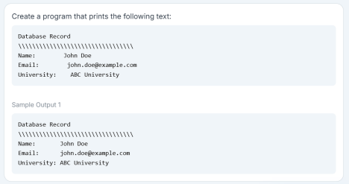

**Problem 3. Input Operations**

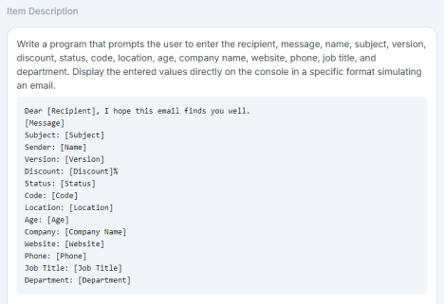

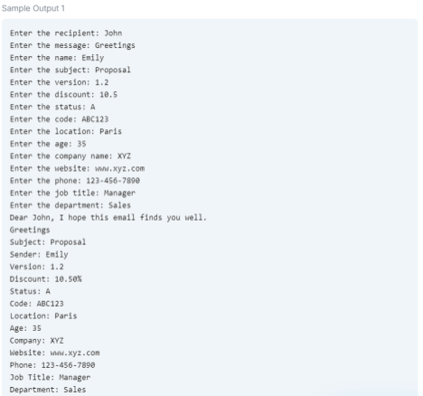**Problem 4. Using Placeholders with % specifier**

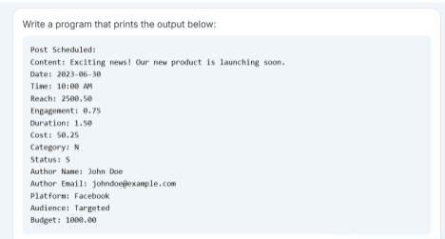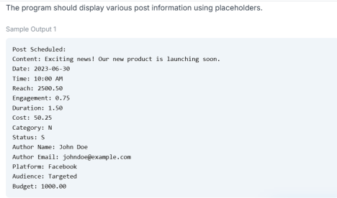

**Problem 5. Type Casting**

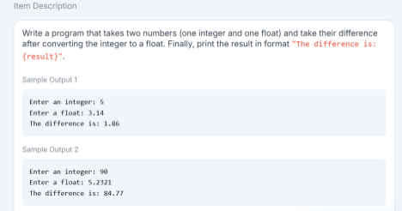**-end-**